Morgan State University
Quantum Laboratory Sequence

Quantum Lab #1: Polarization Entanglement – Violating Bell’s Inequality

Background

The definition of an entangled state in quantum physics can be rather simple: It says two quantum objects cannot be described separately anymore, only together. For example, the polarization-entangled state of two particles given by below state representation cannot be factored (H = horizontal polarization; V = vertical polarization):

In other words we cannot factor the state of one particle, say |V>, from the total wave function. If one wants to show that a quantum system is entangled, usually a so-called “Bell inequality” is employed. In the case of polarization entangled photon pairs, the so-called CHSH inequality is often used, as conceived by Clauser, Horne, Shimony and Holt.

The correlations between the states of two particles, whether entangled or not, can be calculated using coincidence counting for different combinations of the known states for particle 1 and particle 2. As shown in Fig. 1, the photon pair source, which might be producing polarization-entangled photons depending on the setup, sends each photon into separate detectors. Each detector has a defined polarizer in front, so only those photons having the same polarization as the polarizer will transit at 100% (photons with polarization not aligned with the polarizer will arrive at the detector less than 100%). The coincidence instrumentation counts how many times both photons arrive simultaneously.
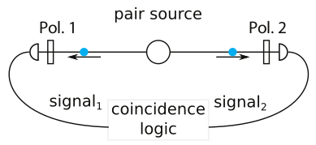
Figure 1. A photon pair source producing photons with certain polarizations can be measured with separate detectors that have defined polarizer orientations in front. The coincidence instrumentation counts how many photons arrive simultaneously for a given setup.

Let's assume the horizontal direction defines 0° polarization. The maximum polarization angle is then 180° (any larger angles are redundant). Thus, vertical polarization means setting a polarizer to 90°. It is known that the coincidence count rate for photon pairs of polarization

Classical (“local realistic”) theories predict that a certain value “S” has an upper bound of 2 (meaning S<=2). When quantum theory is used to calculate the corresponding value, S can exceed a value of 2, the new bound is 2*sqrt(2).

Practically, the S value is determined by measuring the coincidence count rate at 16 different polarizer settings and adding and subtracting these values.

Reference: Textbook Section

Lab Setup

Connect the fiber optics to the Avalanche Photodiode (APD) ports #1 and #2 of the quED Control & Readout (quCR) unit as shown in Figure 2.
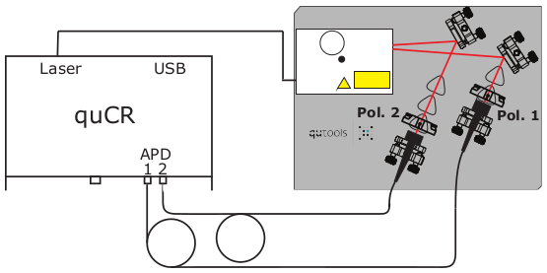
Figure 2. Setup for the Violating Bell's Inequality experiment

